**Capstone Project**

**Hotel Booking Analysis**

**By:**

**Abhishek Kumar Mishra**

**Table Of Content :**

* Objective
* Data summary
* Univariate analysis
* Hotel wise analysis
* Booking cancellation analysis
* Distribution Channel wise analysis
* Conclusion

**Objective**

Aim : To discuss the analysis of given hotel bookings data set.

We’ll be doing analysis of given data set in following ways :

* + Univariate analysis
  + Hotel wise analysis
  + Distribution Channel wise analysis
  + Booking cancellation analysis

Trying to find out key factors driving the hotel bookings trends.

# Data Summary:

Data set has different columns of variables crucial for hotel bookings. Some of them are:

Hotel : The category of hotels, which are two resort hotel and city hotel.

is_cancelled : The value of column show the cancellation type.

lead_time : The time between reservation and actual arrival.   
stayed_in_weekend_nights : The number of weekend nights stay per reservation stayed_in_weekday_nights: The number of weekday nights stay per reservation.  
Meal: Meal preferences per reservation.  
Country: The origin country of guest.

**Data Summary**(contd..)

Market_segment: This column show how reservation was made and what is the purpose

of reservation.

distribution_channel:Medium through booking was made.

Is_repeated_guest: Shows if the guest is who has arrived earlier or not.Values[0,1]-->0

indicates no and 1 indicated yes person is repeated guest.   
days_in_waiting_list: Number of days between actual booking and transact. customer_type: Type of customers( Transient, group, etc.)

# Data Summary

## Univariate Analysis

While doing univariate analysis of given hotel booking dataset, we answered following questions:

* + 1. Which agent makes most no. of bookings?
    2. Which room type is in most demand and which room type generates highest adr?

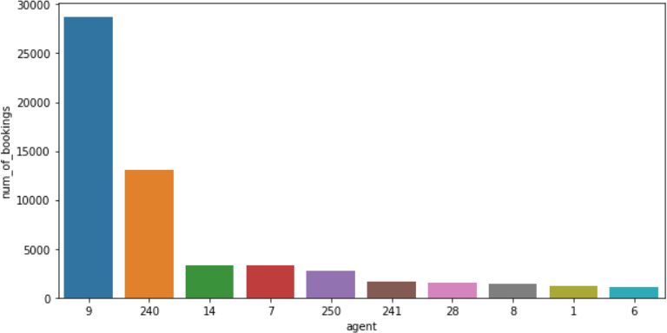

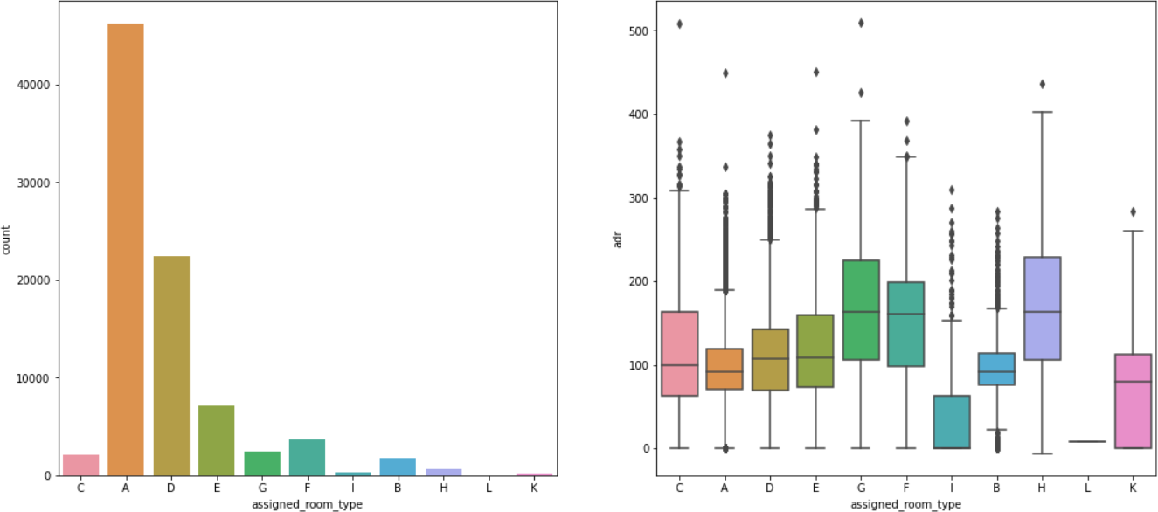

* Type A room is most demanded by customers.
* Agent with id no. 9 made most of the bookin

## Hotel wise Analysis

While doing hotel-wise analysis of given hotel booking dataset, we answered following questions:

* + 1. What is percentage of bookings in each hotel?
    2. Which hotel seems to make more revenue?
    3. Which hotel has higher lead time?
    4. What is preferred stay length in each hotel?

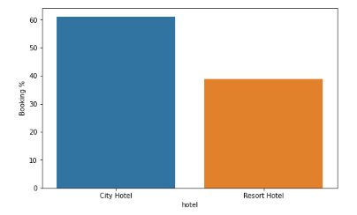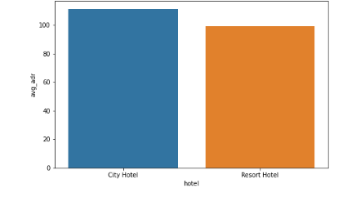

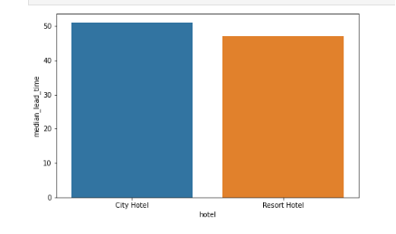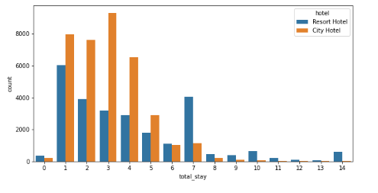

**Distribution channel wise Analysis:**

While doing Distribution channel wise analysis of given hotel booking dataset:

* + 1. Which is the most common channel for booking hotels?
    2. Which distribution channel brings better revenue generating deals for hotels?
    3. Which channel is mostly used for early booking of hotels?
    4. Which distíibution channel bíings betteí íevenue geneíating deals foí hotels?

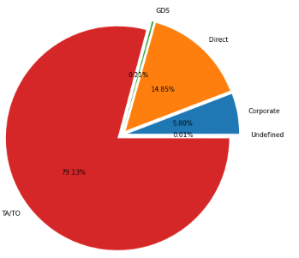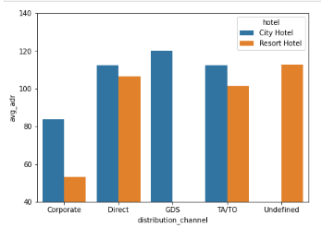

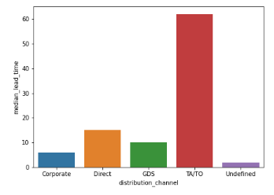

## Booking cancellation Analysis

Following possible reasons for booking cancellations:

1. Which is significant distribution channel has highest cancellation percentage?

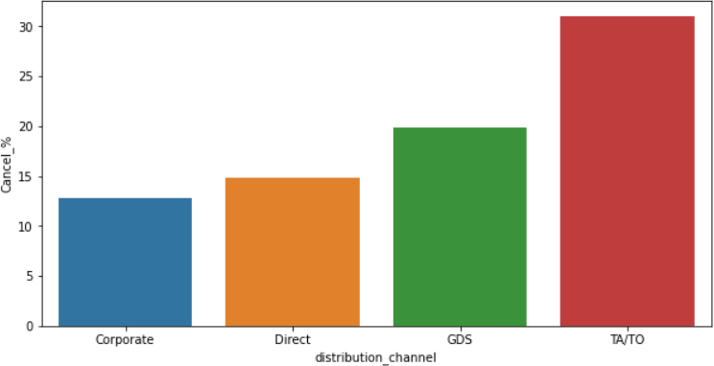

Correlation Heatmap

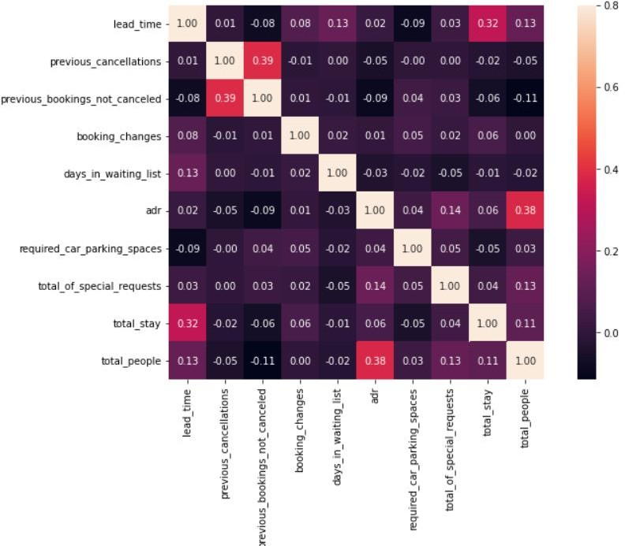

# Conclusion

Following Conclsion are made :

* City Hotel seems to be more preferred among travelers and it also generates more revenue.
* Most number of bookings area made at cit hotel.
* GDS channel brings higher revenue generating deals for City hotel.
* TA/TO has highest booking cancellation %.

**Thank You**